Heidi Neilson is the Head of Environment at the Port of Oslo
Neilson holds a master degree in Geography, and a bachelor degree in Environmental Management. The mix of natural and social sciences is useful since the port’s environmental impact as well as the influence on city development is important in the Oslo Fjord City of Norway.
In the environmental field, the Port of Oslo functions in close relation with other authorities in the city and scientists who provide important knowledge. “The city and port of Oslo have a zero emission action plan. We want to grow, but at the same time reduce the carbon emission by 85 % in 2030. To accomplish this we need innovation and partnership with cargo owners, shipping lines and the city as a buyer of sea transport. The maritime city of Oslo use sea transport as part of our capital region cargo logistics. This is smart because sea transport is by far the most energy efficient mode of transport. An efficient port removes cargo from roads between Norway and Europe. This does reduce a large amount of global carbon emissions from the transport sector, and there is more capacity in short sea shipping available. City ports, like Oslo, need to provide services that compete with road transport. The seaway is the low emission highway from Europe, and all port cities should take the opportunity to reduce global emission, by providing efficient port services and use more sea transport in the urban logistic cargo chains”, says Neilson.
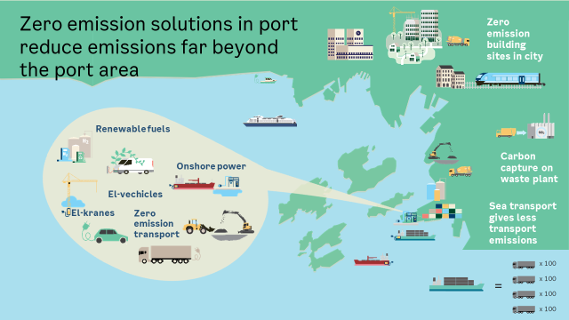
The city of Oslo are working hard to reduce 95 % by 2030. The port aims for 85 % by 2030, and becoming a zero emission port by 2050. The port city of Oslo was the European Green Capital in 2019. A common goal for all the sectors in our city is to walk the path towards a zero emission future together.
Key points
- Finding innovative partners to build zero emission infrastructure both for land & sea transport
- Sea transport is part of port city cargo logistic chains, embrace zero emission solutions
- What can we do together to provide zero emission solutions in city ports across the world?

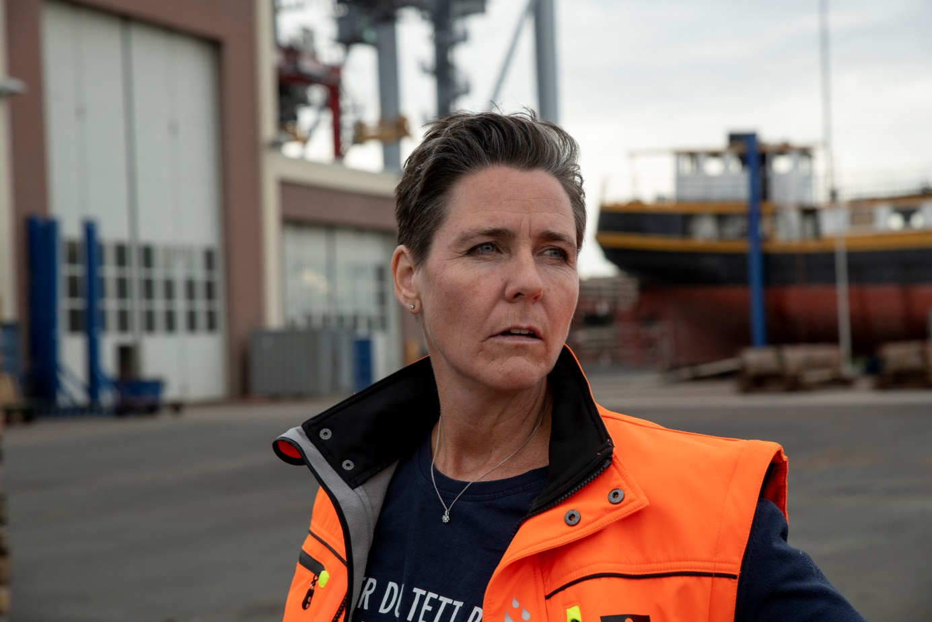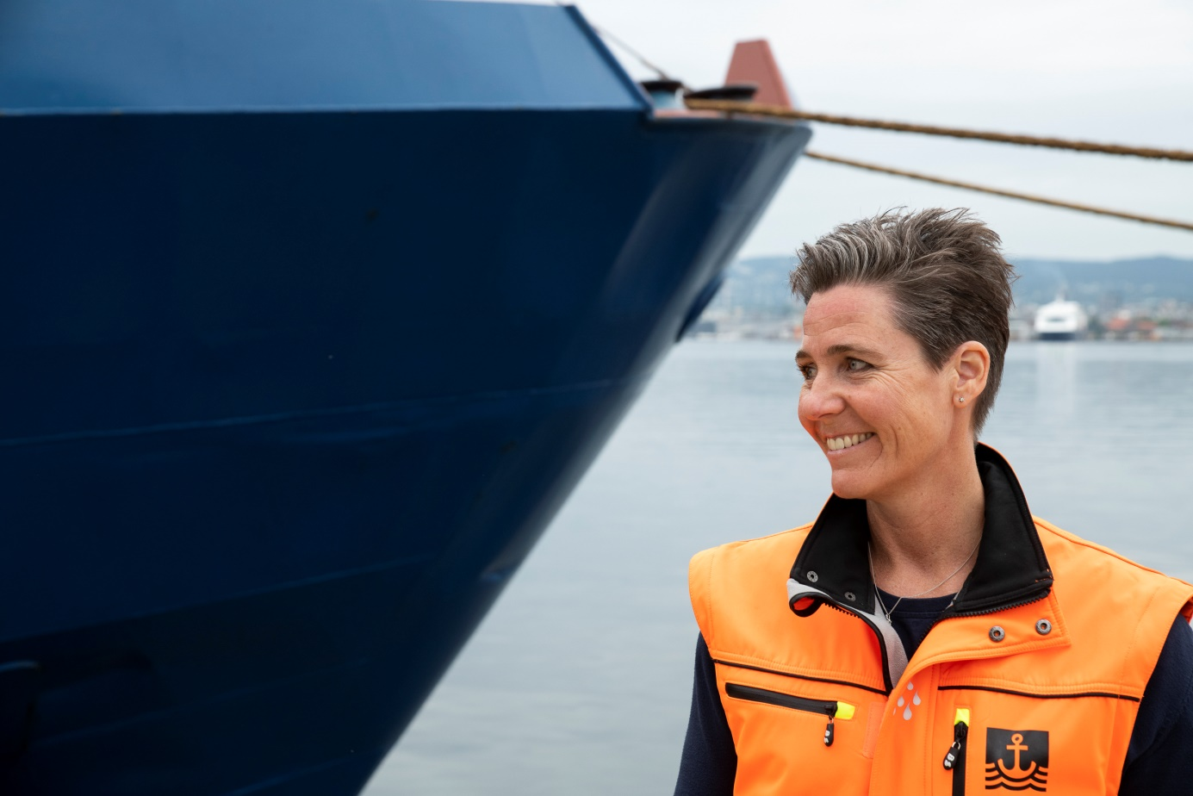
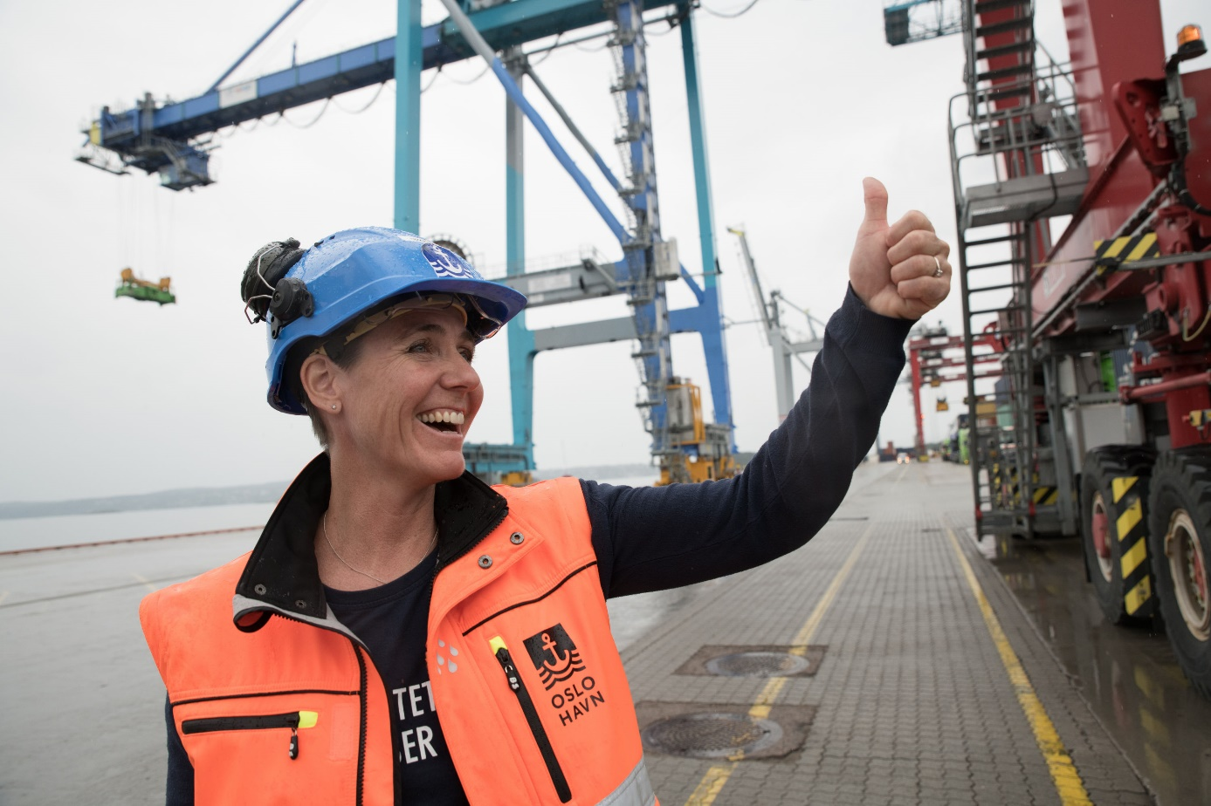Photo: Port of Oslo/Hans Kristian Riise
You can find me at LinkedIn.
Heidi Neilson
Head of Environment
Oslo Havn KF/Port of Oslo
Oslo Kommune/City of Oslo

Mobil: +47 476 01 857
heidi.neilson@oslohavn.no

www.oslohavn.no / www.oslo.kommune.no

